G VENKATA SRIDHAR  gvsridhar.devops@gmail.com
+91-9739964629

KUBERNETES
Container Orchestration
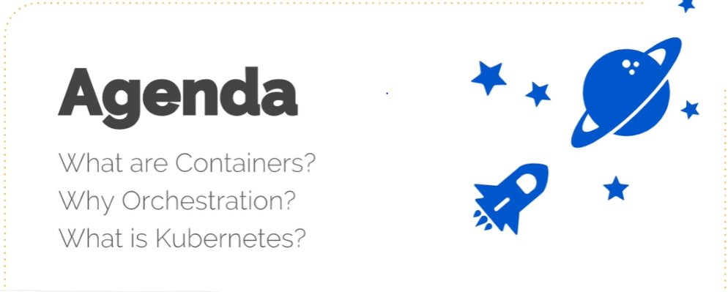
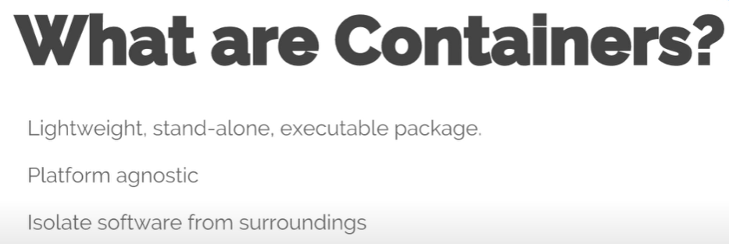



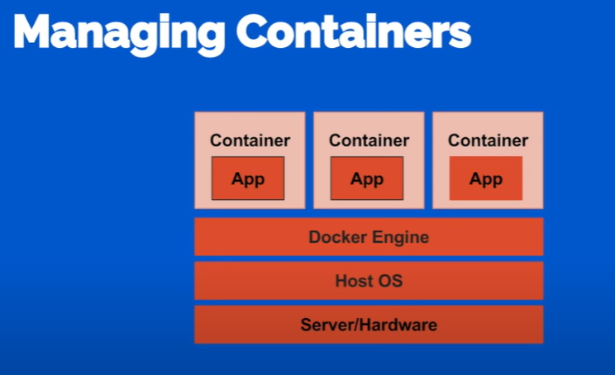
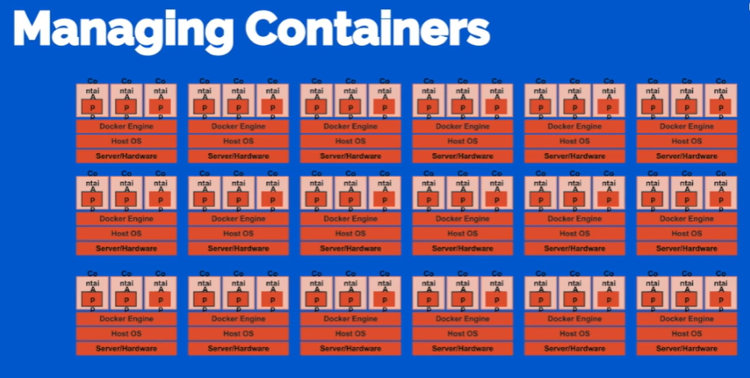

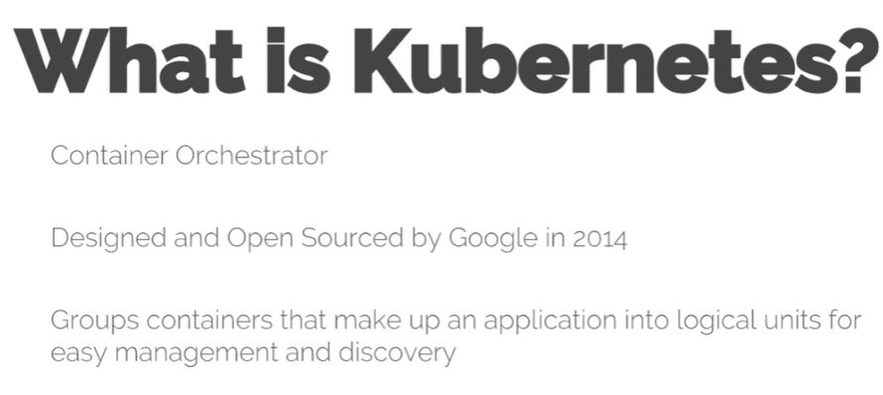

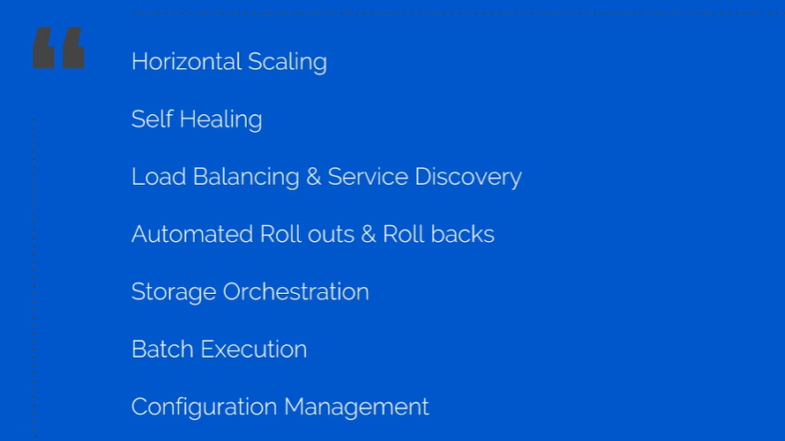

Kubernetes Architecture
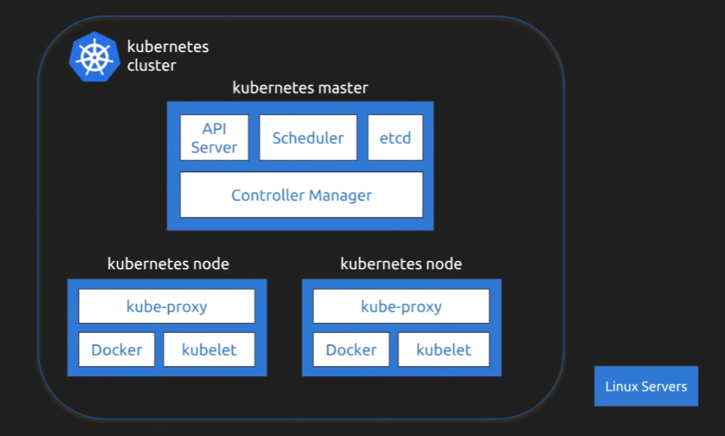

API Server → Communicates between Kubernetes Cluster & Kubernetes Master.
Scheduler → Communicates between Kubernetes Master & Kubernetes Slave/Nodes/Minions
Etcd → Consists of key-value properties and contains metadata of Kubernetes Master/Cluster
Controller Manager → is a daemon and mainly useful for managing nodes and its information.

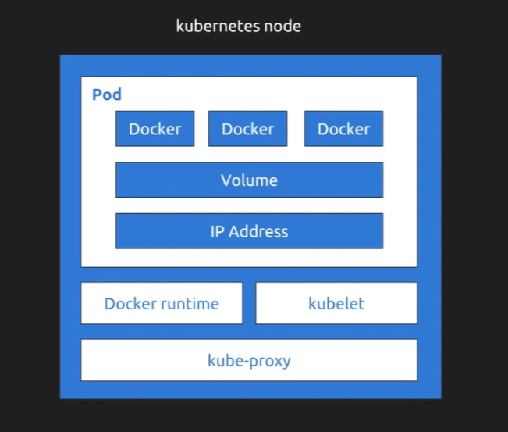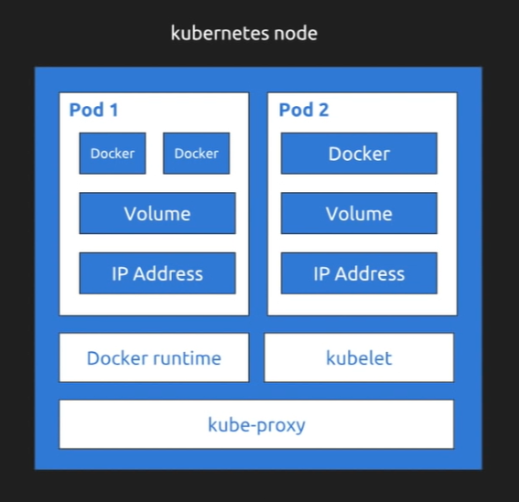

POD → It is a small unit which helps us to create containers & deploy the containers.
Kube-Proxy → Communicates between NODE to NODE (Kubernetes Nodes through Network)
Docker Runtime →
Kubelet → Consists of key-value properties and contains metadata of Kubernetes Nodes
IP Address → Useful for communicating between from POD to POD is a daemon and mainly useful for
Volume → for persistent storage
Docker → Creates containers

Kubernetes Architecture | Service and Deployment
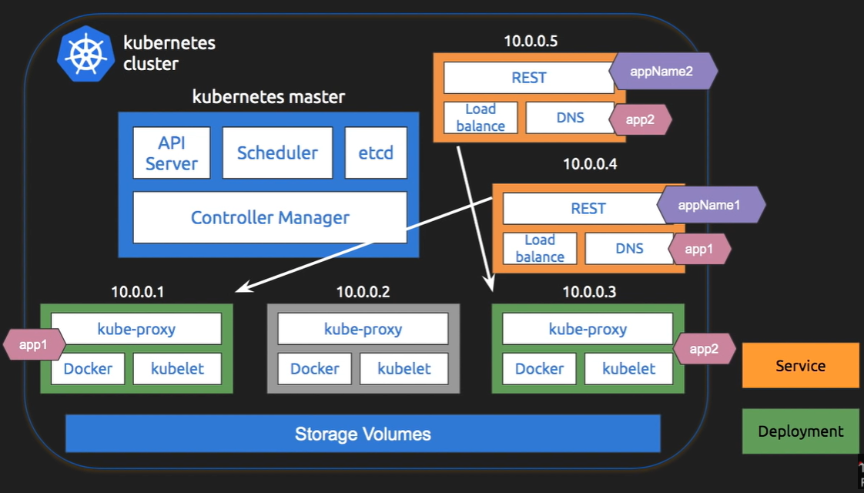

Deploying Spring Boot in Kubernetes | Google Kubernetes Engine

OpenShift Container Platform by RedHat | Kubernetes Made Easy
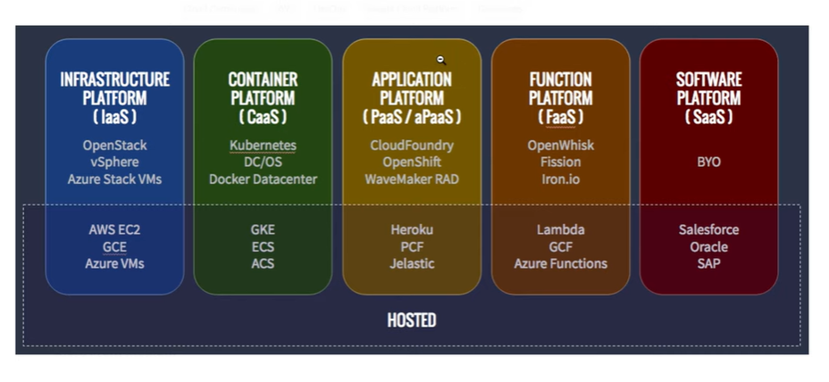

Kubernetes Network
